

**INFORMATION SYSTEM DESIGN AND SOFTWARE ENGINEERING LAB**

Data flow and use case diagram

Teacher-Student

Collaboration System

Submitted by

**Mahir Rashid** | 15-01-04-011

**Tasnim Mashrur mahee** | 15-01-04-013

**Atiqul Islam Chowdhury** | 15-01-04-014

**Md. Saiful Islam** | 15-01-04-027

CSE 3224

**Introduction:**

After completing the interview or data collection part, we are trying to construct data flow diagram and use case diagram for our project. A data flow diagram (DFD) is a graphical representation of the "flow" of data through an information system, modeling its process aspects. DFD can provide a high level system overview, complete with boundaries and connections to other systems. It mainly illustrates how data is processed by a system in terms of inputs and outputs.

**Processes Followed for the Creation of the DFD:**

* Creation of a list of activities
* Construction of a Context Level DFD containing the main process and the External Entities
* Construction of level-0 DFD identifying manageable sub processes and and basic data stores
* Construction of level-1 DFD
* Cross-check to see if all properties are maintained

**Types of Data Flow Diagram:**

* Context Diagram
* Level 1 Diagram
* Level 2 Diagram

**Context Diagram (Level 0):**

DFD Level 0 is also called a Context Diagram. It’s a basic overview of the whole system or process being analyzed or modeled. It’s designed to be an at-a-glance view, showing the system as a single high-level process, with its relationship to external entities. It should be easily understood by a wide audience, including stakeholders, business analysts, data analysts and developers.

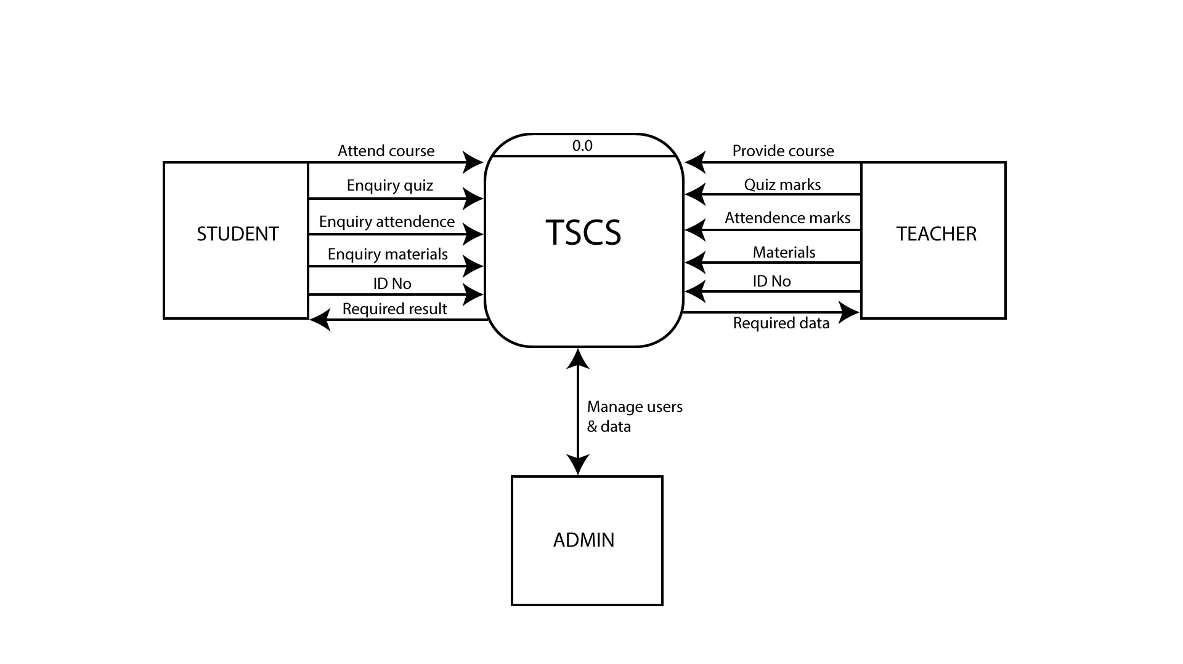

**Description:**

Here, we have three entities in our TSCS system. They are – Admin, Teacher, Student. Student can add course to the system. They can also enquiry quiz, enquiry attendance, enquiry materials and add an ID to the system. On the other hand, Teacher can provide course, quiz marks, attendance marks, materials to the system, but system can give teacher the required information/data. And finally admin and system manage users and data altogether.

**Level 0 diagram:**

DFD Level 0 provides a more detailed breakout of pieces of the Context Level Diagram. We have highlight the main functions carried out by the system, as you break down the high-level process of the Context Diagram into its sub processes. Entities are same here, just the system are broken into some sub systems.

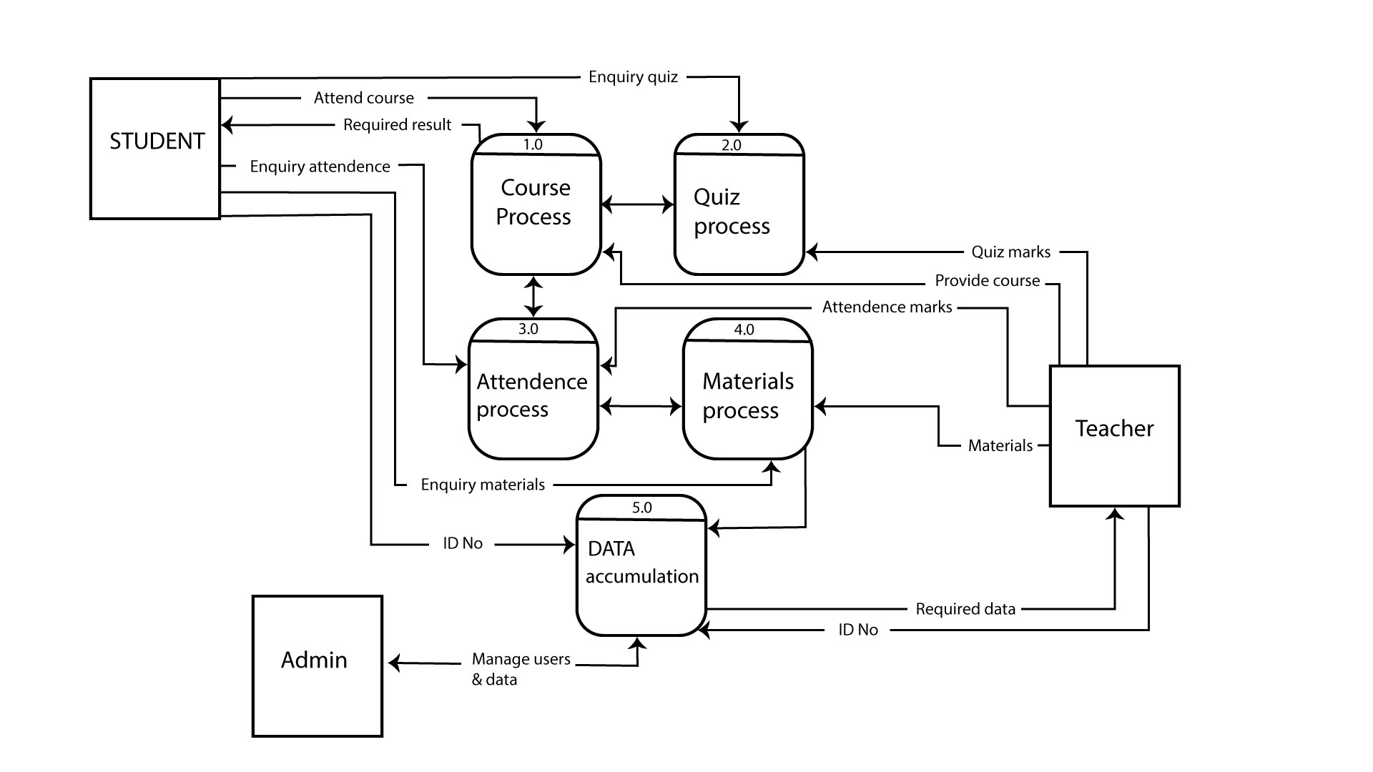

**Description:**

Here, the main system is converted into five sub systems. They are – Course process, Quiz process, Attendance process, Materials process, Data accumulation. Entities remain same. First of all, student can attend course and it will be saved to the course process, and course process system provide the result to the student. Similarly, student entity is connected to the quiz process, attendance process, materials process and data accumulation process. There is a connection from both entity and system. Then, for teacher entity, same things are shown here. Teacher can provide materials to the materials process system, give quiz marks to the quiz process system etc. And finally admin entity and data accumulation system are connected to each other for managing the data and users.

**Level 1 Diagram:**

DFD Level 1 then goes one step deeper into parts of Level 0. The Level 1 DFD shows how the system is divided into sub-systems (processes), each of which deals with one or more of the data flows to or from an external agent, and which together provide all of the functionality of the system as a whole.

**Process-1: Course Process:**

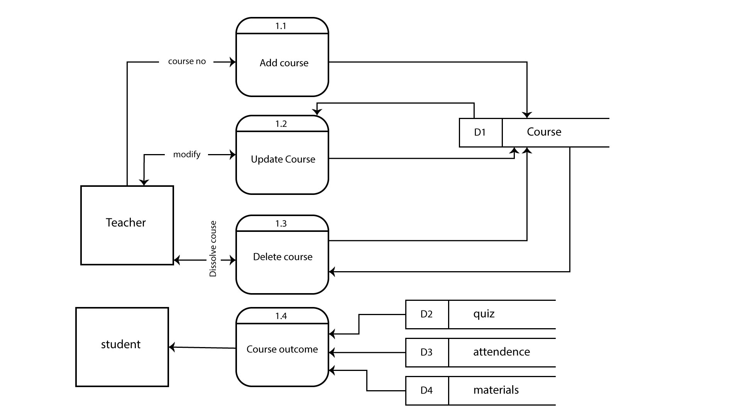

In Level-1, the course process is converted into three process- add course, update course, delete course. Teacher can add, update, delete course if he/she has no interest to take it. Then the course related information will be saved in database D1. Teacher can update it later, change it or remove it anytime.

**Process-2: Quiz Process:**

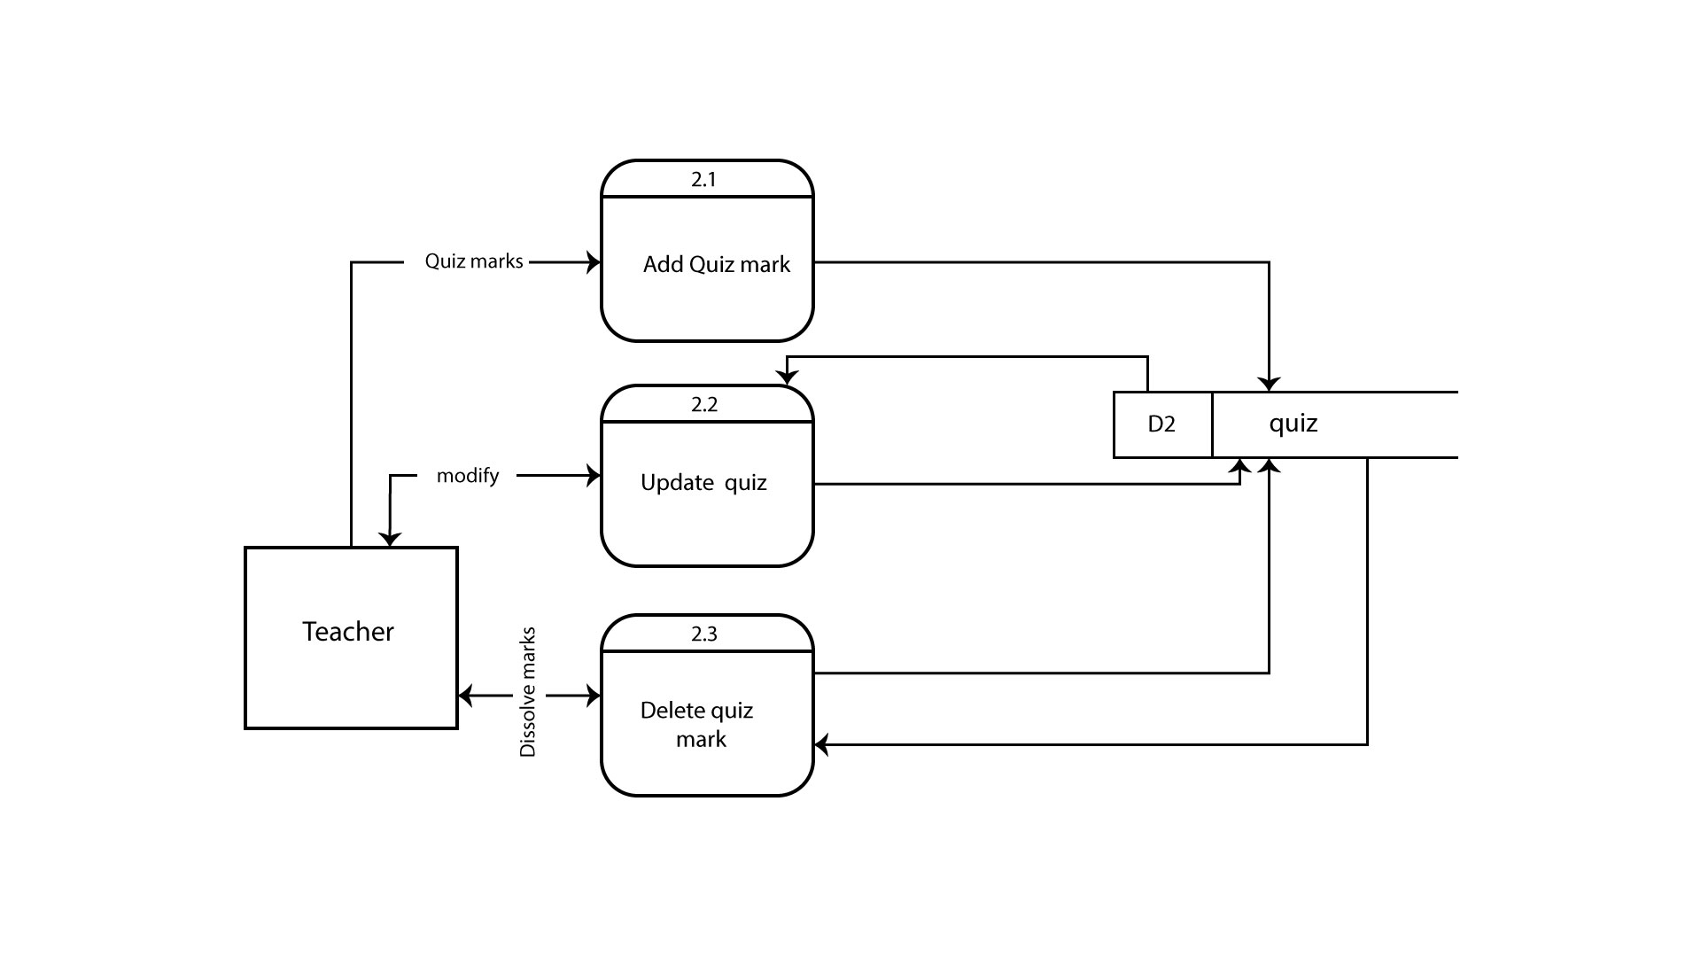

In this process, teacher can add quiz mark, delete quiz mark and update quiz mark to the database.

**Process-3: Attendance Process:**

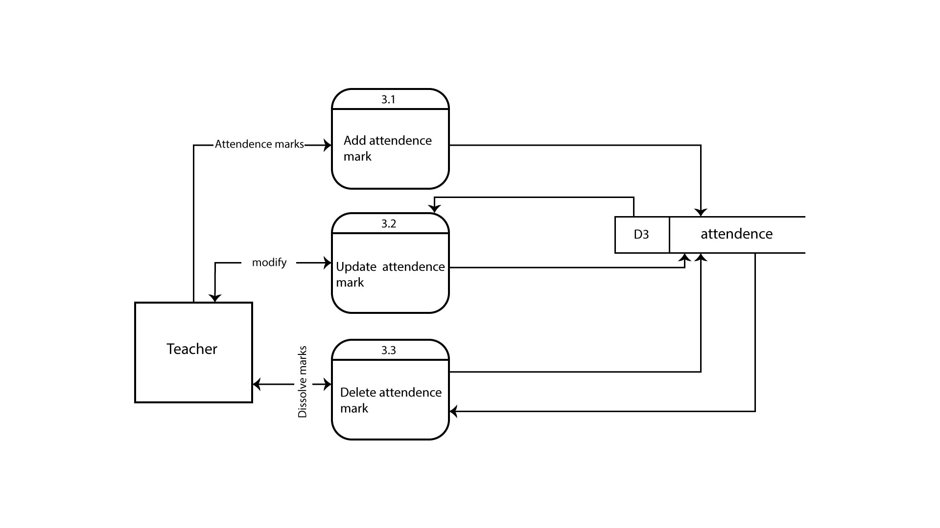

In this process, teacher can add the attendance marks of the student, change the marks and can delete the marks if he/she wants.

**Process-4: Materials Process:**

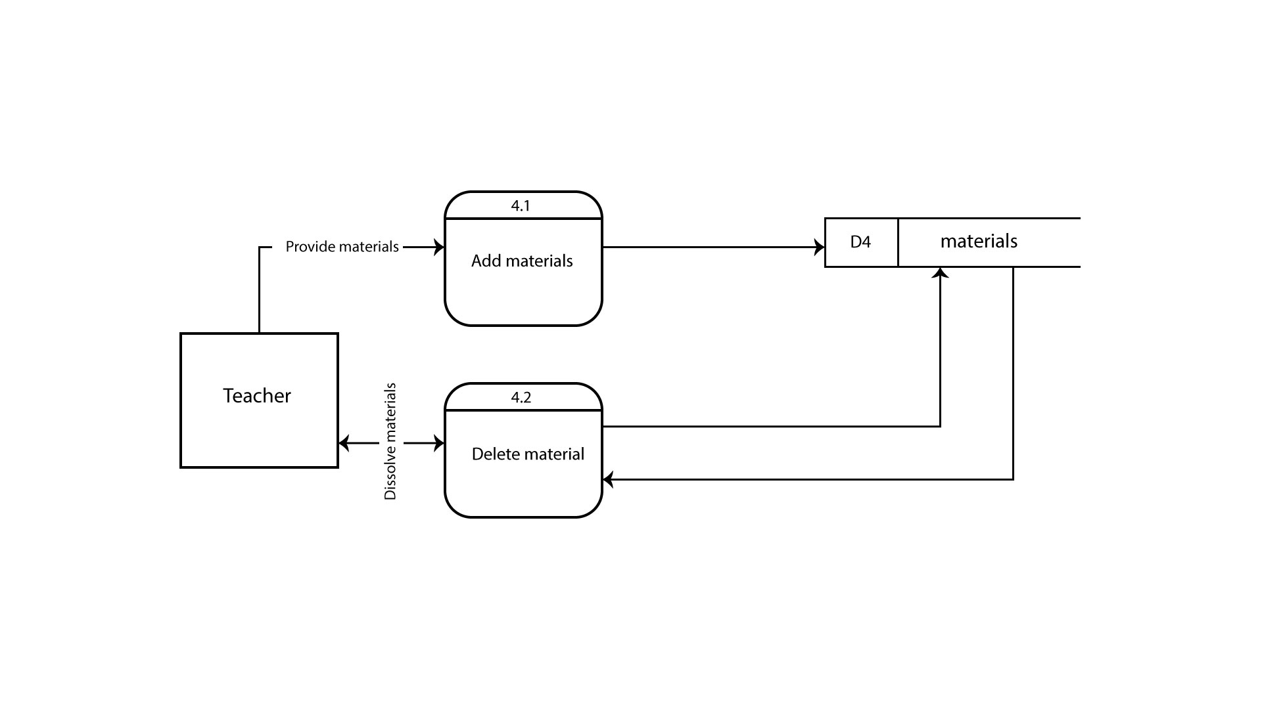

This process depends on teacher. Teacher can add course materials to the system, and if there is no need of some materials, then he/she can delete it easily.

**Process-5: Data Accumulation:**

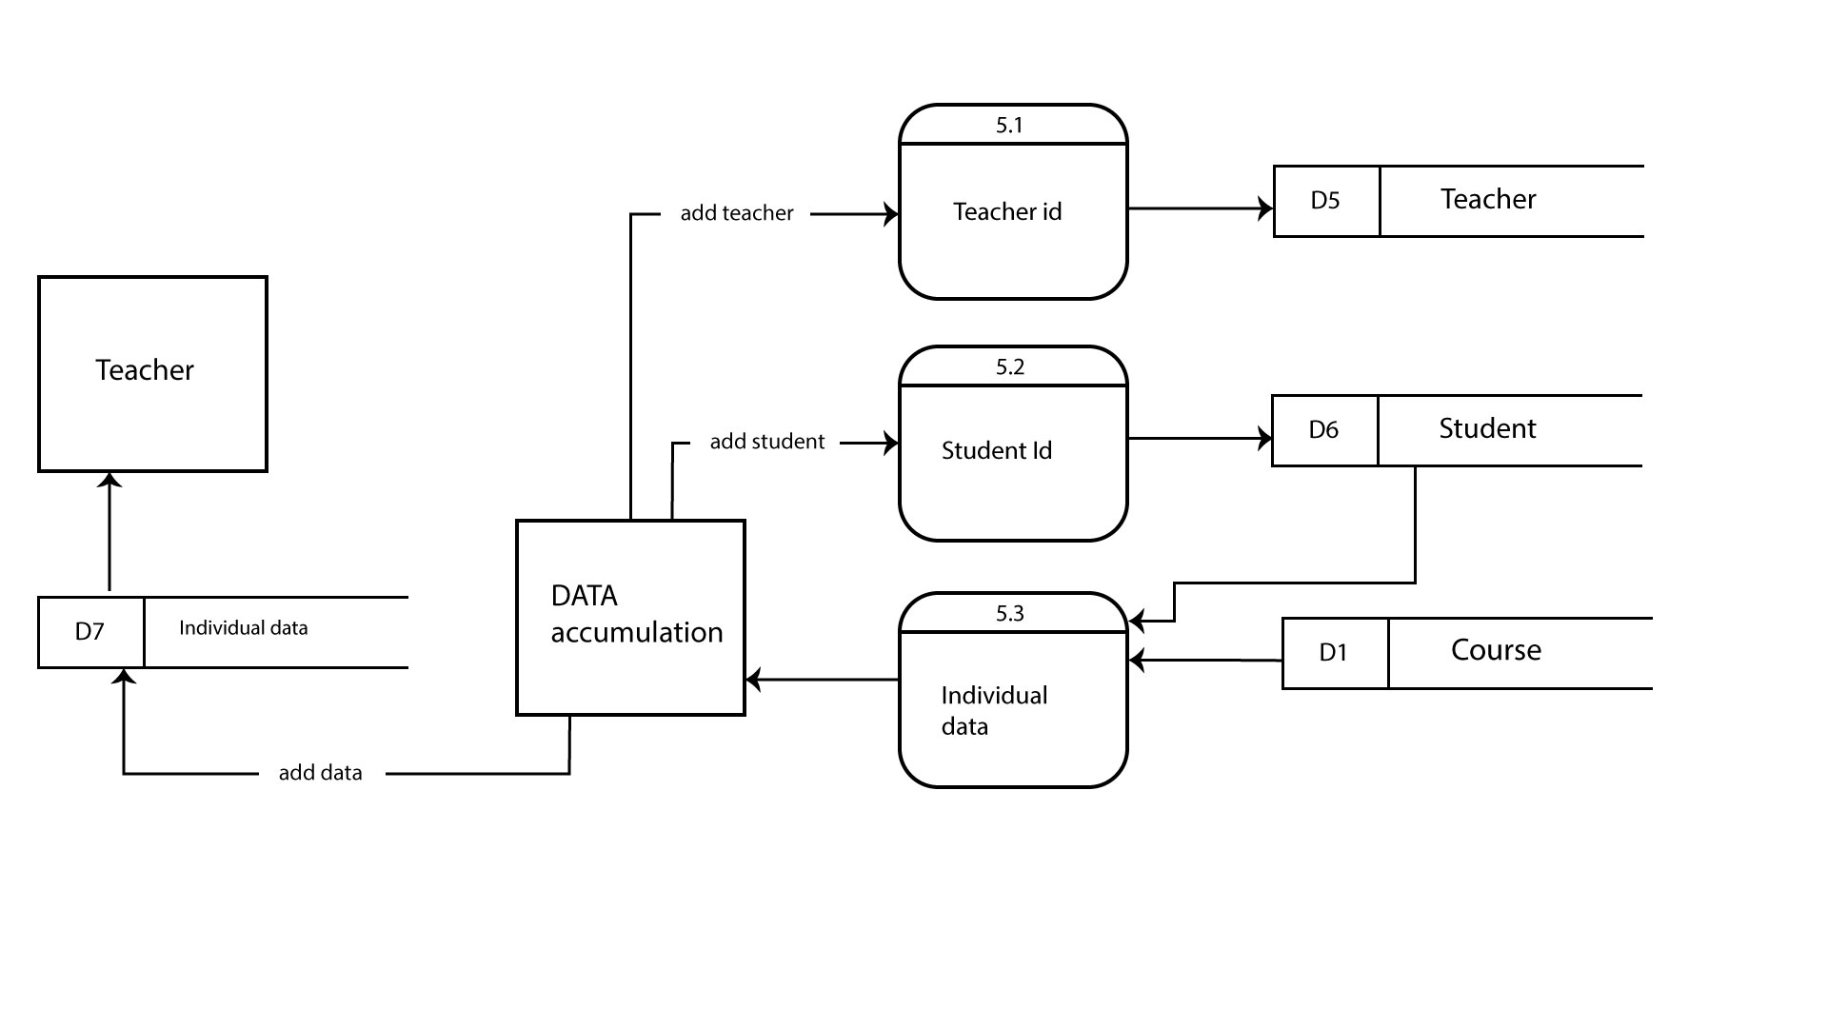

Here, individual data of teachers and students will be shown. There are teacher id, student id, course no, course name which are saved individually to the system. And every students’ information and course related information will be saved individually so that any teacher can see his/her course information along with the students who are involved in it.

**Use Case Diagram:**

Use case diagrams are usually referred to as behavior diagrams used to describe a set of actions (use cases) that some system or systems (subject) should or can perform in collaboration with one or more external users of the system (actors). Each use case should provide some observable and valuable result to the actors or other stakeholders of the system.

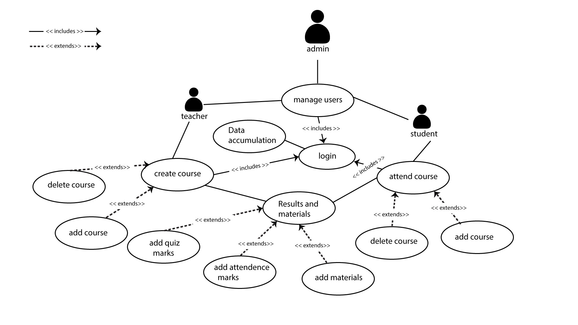

**Actors:**

* **Admin:**   
  Admin can manage users and control the system, also check ta data stores in the database.
* **Teacher:**

Teacher is the most important actor in this system. Any teacher can create course, add marks of quiz and attendance, add materials to the system.

* **Student:**

Student can take courses, get marks of quiz and attendance from the system and also get course related information and materials from the system.

**Use Case:**

* **Manage Users**

Actor: Admin

Pre-Condition: Login

Primary path:

* Manage and check the information about teachers and students

Alternative path:

* It does not have information
* **Login**

Actor: Teacher, Student

Pre-Condition: None

Primary path:

* Enter user id
* Enter email id
* Enter password

Alternative path:

* Wrong user id
* Wrong email id
* Wrong password
* **Create Course**

Actor: Teacher

Pre-Condition: Login

Primary path:

* Create a new course
* Provide course information
* Add/Delete course

Alternative path:

* No course taken
* **Attend Course**

Actor: Student

Pre-Condition: Login

Primary path:

* Take a new course
* Get course information
* Add/Delete course

Alternative path:

* No course taken
* **Results and Materials**

Actor: Teacher

Pre-Condition: Create course

Primary path:

* Share materials
* Share quiz and attendance results

Alternative path:

* No materials shared
* No quiz and attendance taken
* **Results and Materials**

Actor: Student

Pre-Condition: Attend course

Primary path:

* Get materials
* Get the quiz and attendance results

Alternative path:

* Found no materials
* Found no quiz and attendance results
* **Data Accumulation**

Actor: Admin

Pre-Condition: Login

Primary path:

* Store the data and information of teachers and students

Alternative path:

* No data found

**Conclusion:**

This concludes data flow overview of our application development process. In this process we got a clear view of different aspects of the project. By data flow diagram and use case diagram we got a specific vision for the project. Now we can proceed to implement this system.